Name: P V GIRIDHAR
Reg. No: 1972260022
Exercise 5
AIM:
To write a Python program using NumPy arrays and arithmetic operations to calculate the average fuel efficiency of different car models and the percentage improvement in fuel efficiency between two car models.
ALGORITHM:
Step 1: Start.
Step 2: Import the NumPy library.
Step 3: Create the array fuel_efficiency holding the miles per gallon of each car model.
Step 4: Calculate the average fuel efficiency as the mean of all the elements.
Step 5: Select the two car models to compare: the old model and the new model.
Step 6: Calculate the percentage improvement = (new - old) / old x 100.
Step 7: Display the fuel efficiency values, the average and the percentage improvement.
Step 8: Stop.
PROCEDURE:
- Import the NumPy library as np.
- Create the 1-D array fuel_efficiency holding the miles per gallon (mpg) of each car model.
- Calculate the average fuel efficiency using np.mean(fuel_efficiency).
- Select the two models to compare using indexing: Model 1 (index 0) as the old model and Model 5 (index 4) as the new model.
- Calculate the percentage improvement using the formula (new - old) / old x 100.
- Print the fuel efficiency values, the average and the percentage improvement.
INPUT AND OUTPUT:
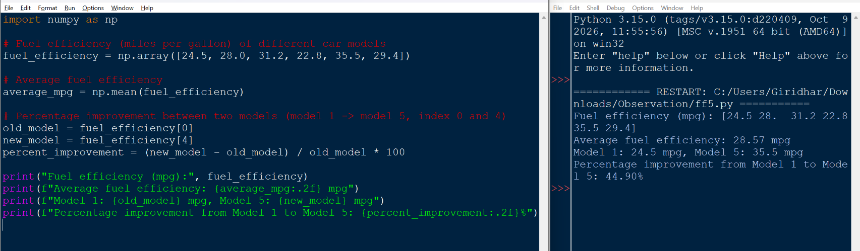
RESULT:
The average fuel efficiency is 28.57 mpg. The fuel efficiency improves from 24.5 mpg (Model 1) to 35.5 mpg (Model 5), which is a percentage improvement of 44.90%. Thus the program was executed successfully and the output was verified.

